Priority scheduling (premptive)
#include <stdio.h>

struct Process
{
int pid, at, bt, pr;
int rt, ct, tat, wt;
};

int main()
{
struct Process p[20];
int n, time = 0, completed = 0;
int index;
float total_tat = 0, total_wt = 0;

printf("Enter number of processes: ");
scanf("%d",&n);

for(int i=0;i<n;i++)
{
p[i].pid = i+1;

printf("Enter AT BT Priority for P%d: ",i+1);
scanf("%d%d%d",&p[i].at,&p[i].bt,&p[i].pr);

p[i].rt = p[i].bt;
}

while(completed < n)
{
index = -1;

for(int i=0;i<n;i++)
{
if(p[i].at <= time && p[i].rt > 0)
{
if(index == -1 ||
p[i].pr < p[index].pr ||
(p[i].pr == p[index].pr && p[i].at < p[index].at) ||
(p[i].pr == p[index].pr && p[i].at == p[index].at && p[i].pid < p[index].pid))
{
index = i;
}
}
}

if(index == -1)
{
time++;
continue;
}

p[index].rt--;

if(p[index].rt == 0)
{
completed++;

p[index].ct = time + 1;
p[index].tat = p[index].ct - p[index].at;
p[index].wt = p[index].tat - p[index].bt;
}

time++;
}

printf("\nPID\tAT\tBT\tPR\tCT\tTAT\tWT\n");

for(int i=0;i<n;i++)
{
printf("P%d\t%d\t%d\t%d\t%d\t%d\t%d\n",
p[i].pid,p[i].at,p[i].bt,p[i].pr,
p[i].ct,p[i].tat,p[i].wt);

total_tat += p[i].tat;
total_wt += p[i].wt;
}

printf("\nAverage Turnaround Time = %.2f", total_tat/n);
printf("\nAverage Waiting Time = %.2f\n", total_wt/n);

return 0;
}
Output
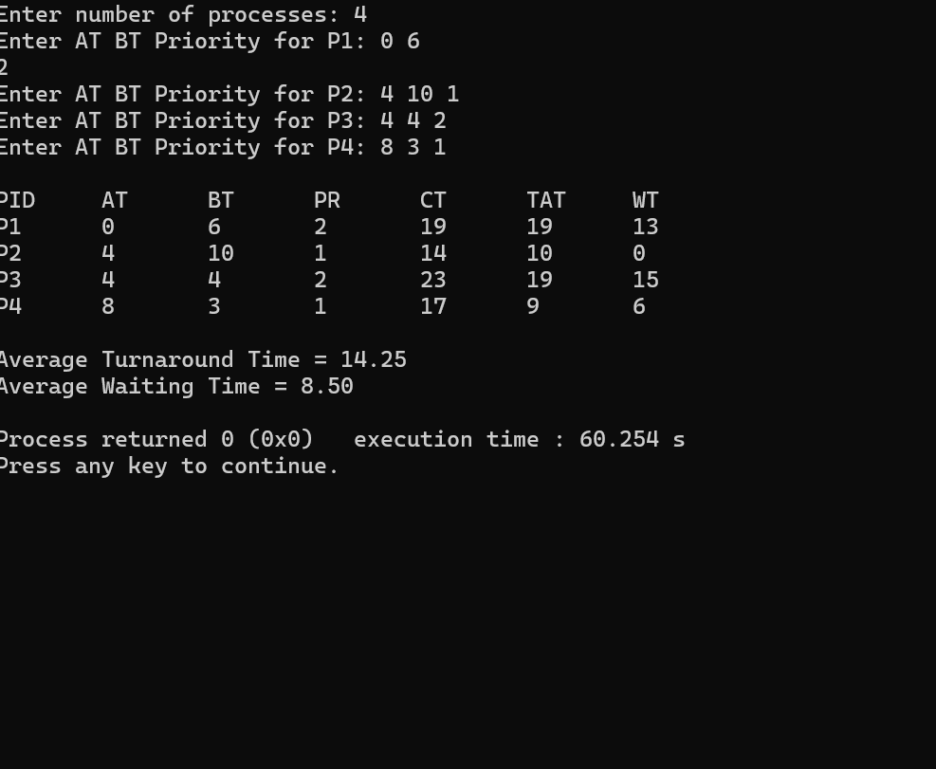
Priority scheduling(Non Premptive)
#include <stdio.h>

struct Process
{
int pid;
int at;
int bt;
int pr;
int ct;
int tat;
int wt;
int completed;
};

int main()
{
struct Process p[20];
int n, time = 0, completed = 0;
int index;
float total_tat = 0, total_wt = 0;

printf("Enter number of processes: ");
scanf("%d",&n);

for(int i=0;i<n;i++)
{
p[i].pid = i+1;
p[i].completed = 0;

printf("Enter AT BT Priority for P%d: ",i+1);
scanf("%d%d%d",&p[i].at,&p[i].bt,&p[i].pr);
}

while(completed < n)
{
index = -1;

for(int i=0;i<n;i++)
{
if(p[i].at <= time && p[i].completed == 0)
{
if(index == -1 ||
p[i].pr < p[index].pr ||
(p[i].pr == p[index].pr && p[i].at < p[index].at) ||
(p[i].pr == p[index].pr && p[i].at == p[index].at && p[i].pid < p[index].pid))
{
index = i;
}
}
}

if(index == -1)
{
time++;
continue;
}

time += p[index].bt;

p[index].ct = time;
p[index].tat = p[index].ct - p[index].at;
p[index].wt = p[index].tat - p[index].bt;

p[index].completed = 1;
completed++;
}

printf("\nPID\tAT\tBT\tPR\tCT\tTAT\tWT\n");

for(int i=0;i<n;i++)
{
printf("P%d\t%d\t%d\t%d\t%d\t%d\t%d\n",
p[i].pid,p[i].at,p[i].bt,p[i].pr,
p[i].ct,p[i].tat,p[i].wt);

total_tat += p[i].tat;
total_wt += p[i].wt;
}

printf("\nAverage Turnaround Time = %.2f", total_tat/n);
printf("\nAverage Waiting Time = %.2f\n", total_wt/n);

return 0;
}

Output
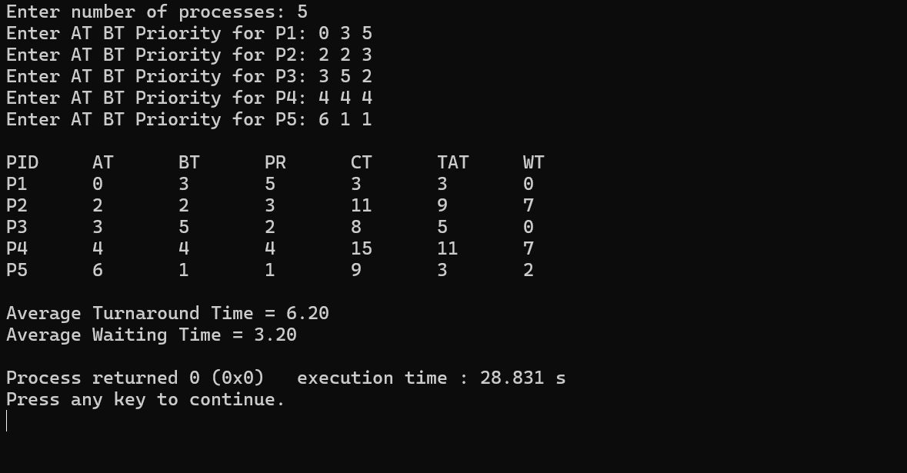
SJF (Non Premptive)
#include <stdio.h>

struct Process
{
int pid;
int at;
int bt;
int rt;
int ct;
int tat;
int wt;
};

int main()
{
struct Process p[20];
int n, time = 0, completed = 0;
int shortest, min_rt;
float total_tat = 0, total_wt = 0;

printf("Enter number of processes: ");
scanf("%d", &n);

for(int i = 0; i < n; i++)
{
p[i].pid = i + 1;

printf("Enter AT and BT for P%d: ", i + 1);
scanf("%d %d", &p[i].at, &p[i].bt);

p[i].rt = p[i].bt; // remaining time
}

while(completed < n)
{
shortest = -1;
min_rt = 9999;

for(int i = 0; i < n; i++)
{
if(p[i].at <= time && p[i].rt > 0)
{
if(shortest == -1 ||
p[i].rt < min_rt ||
(p[i].rt == min_rt && p[i].at < p[shortest].at) ||
(p[i].rt == min_rt && p[i].at == p[shortest].at && p[i].pid < p[shortest].pid))
{
min_rt = p[i].rt;
shortest = i;
}
}
}

if(shortest == -1)
{
time++;
continue;
}

p[shortest].rt--;

if(p[shortest].rt == 0)
{
completed++;

p[shortest].ct = time + 1;
p[shortest].tat = p[shortest].ct - p[shortest].at;
p[shortest].wt = p[shortest].tat - p[shortest].bt;

total_tat += p[shortest].tat;
total_wt += p[shortest].wt;
}

time++;
}

printf("\nPID\tAT\tBT\tCT\tTAT\tWT\n");

for(int i = 0; i < n; i++)
{
printf("P%d\t%d\t%d\t%d\t%d\t%d\n",
p[i].pid,
p[i].at,
p[i].bt,
p[i].ct,
p[i].tat,
p[i].wt);
}

printf("\nAverage Turnaround Time = %.2f", total_tat / n);
printf("\nAverage Waiting Time = %.2f\n", total_wt / n);

return 0;
}

Out put
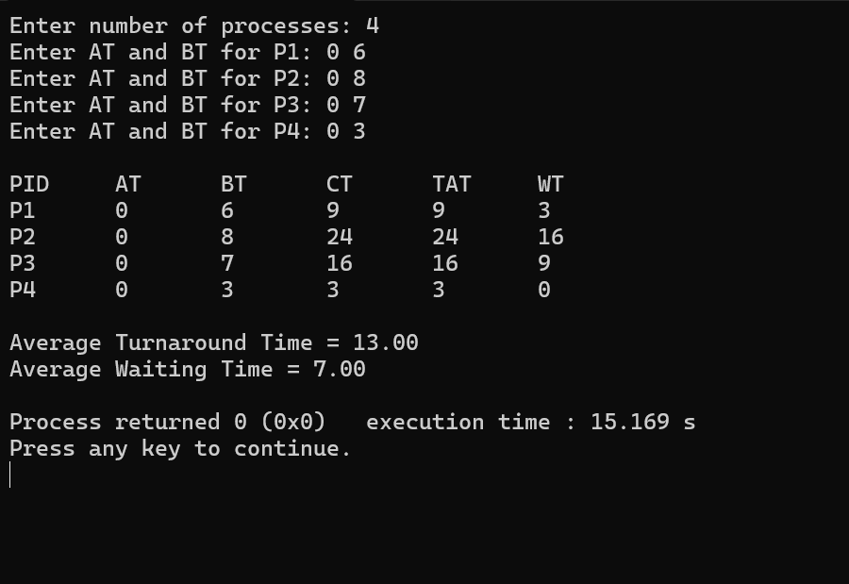
SJF (premptive)
#include <stdio.h>

struct Process
{
int pid;
int at;
int bt;
int rt;
int ct;
int tat;
int wt;
};

int main()
{
struct Process p[20];
int n, time = 0, completed = 0;
int shortest, min_rt;
float total_tat = 0, total_wt = 0;

printf("Enter number of processes: ");
scanf("%d",&n);

for(int i=0;i<n;i++)
{
p[i].pid = i+1;

printf("Enter AT and BT for P%d: ",i+1);
scanf("%d%d",&p[i].at,&p[i].bt);

p[i].rt = p[i].bt;
}

while(completed < n)
{
shortest = -1;
min_rt = 9999;

for(int i=0;i<n;i++)
{
if(p[i].at <= time && p[i].rt > 0)
{
if(shortest == -1 ||
p[i].rt < min_rt ||
(p[i].rt == min_rt && p[i].at < p[shortest].at) ||
(p[i].rt == min_rt && p[i].at == p[shortest].at && p[i].pid < p[shortest].pid))
{
min_rt = p[i].rt;
shortest = i;
}
}
}

if(shortest == -1)
{
time++;
continue;
}

p[shortest].rt--;

if(p[shortest].rt == 0)
{
completed++;

p[shortest].ct = time + 1;
p[shortest].tat = p[shortest].ct - p[shortest].at;
p[shortest].wt = p[shortest].tat - p[shortest].bt;

total_tat += p[shortest].tat;
total_wt += p[shortest].wt;
}

time++;
}

printf("\nPID\tAT\tBT\tCT\tTAT\tWT\n");

for(int i=0;i<n;i++)
{
printf("P%d\t%d\t%d\t%d\t%d\t%d\n",
p[i].pid,
p[i].at,
p[i].bt,
p[i].ct,
p[i].tat,
p[i].wt);
}

printf("\nAverage Turnaround Time = %.2f", total_tat/n);
printf("\nAverage Waiting Time = %.2f\n", total_wt/n);

return 0;
}

output
